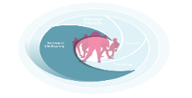
Planning and Progress Review Notification Template

Funded Organisation Name: DCYA UID Code:
ETB Name:
Time period covered in report: From: To:
Proposed date of meeting:
Attending on behalf of the Funded Organisation:

Agenda:
Planning and Progress Review Meetings should cover the following topics. Please attach relevant documentation to the Planning and Progress Review Meeting Notification Template

Standing Agenda: | Please list documents to be sent to ETB
- Review of RAG Action plan

- Review the logic model

- Update on the work with young people and plan for the next reporting period
  - Work Report
  - Work Plan (If available, timetables can be used to supplement this update)
- Findings of unannounced visits (and any areas that may have been flagged as requiring action)
- Review the financial template and drawdown form and discuss and/or agree movement between headings based on actual spend

- AOB

