________________________

Education and Training Board

Business Continuity Planning

Getting Started

The Business Impact Assessment

Table of Contents

________________________ 1
Education and Training Board 1
Business Continuity Planning 1
Getting Started 1
The Business Impact Assessment 1
Table of Contents 2
Introduction: 2
Purpose of Business Continuity Plans 2
Objectives of this Document: 3
Completing the Business Impact Assessment: 3
Business Impact Assessment? 3
Conducting the BIA 3
Business Disruption Scenarios 4
Department / Function Profile 4
Identify Important Contacts: 4
Determining Your Essential Processes / Services 6
Prioritising Your Essential Functions 6
Important terminology 6
RTO – Recovery Time Objective 6
RPO - 6
Core difference 6
Essential Process and Business Impact Analysis Worksheet 7
Conclusion 8
Appendix 1 9
Department / Process Profile 11
Important Contacts Sheet 12
Essential Process and Business Impact Analysis Worksheet 13
Please Provide Any Further Relevant Information 16

Introduction:
Purpose of Business Continuity Plans
Business Continuity Planning (BCP) is designed to help your organisation recover from a disruption in service, either planned or unplanned.
Although infrequent, disasters and emergencies of varying types and severity can occur, often with little or no warning. It is XXETB’s aim that whilst we cannot control when and where such an event occurs that XXETB will aim to manage their ability to maintain operations and the continuance of identified essential functions through effective business continuity planning.
To that end, a business continuity plan (BCP) is a collection of resources, actions, procedures and information that is developed, tested (where feasible), documented and held in readiness for use in the event of a disaster or major disruption of operations.

Objectives of this Document:
The aim of this document is to assist the various functions within XXETB, in the compilation of an overall BCP for the ETB and to ensure the reasonably seamless transition from normal operations in the face of a major disruption or disaster.

Completing the Business Impact Assessment:
Throughout the document there are sample forms included that help to illustrate the specific data that is being collected. For ease of distribution, these forms are all included in Appendix 1 ready to print as many copies as required.

Business Impact Assessment?
The first steps in working towards an effective business continuity plan is to understand the details of systems, people and data requirements throughout the ETB.
To increase our understanding of the risks/ roles and responsibilities throughout the organisation we are going to commence this process with a Business Impact Assessment (BIA) Questionnaire.
A business impact assessment questionnaire and subsequent analysis of same (BIA) predicts the consequences of disruption of a business function or multiple functions and gathers information needed to develop recovery strategies. It is important to note that operations may also be interrupted by the failure of a supplier of goods or services or delayed deliveries. There are many possible scenarios which should be considered.
- Disruption to Payroll
- Disruption to reporting functions, either statutory or regulatory. For example, POD / P-POD returns, October returns, QQI, SOLAS, DES)
- Increased expenses (e.g., overtime labour, outsourcing, expediting costs, etc.)
- Contractual penalties
- Reputational damage following on from an unmanaged disruption to services
- Timing and Duration of Disruption
The point in time when a business function or process is disrupted can have a significant bearing on the loss sustained. For example a payroll system damaged the day of a payroll run going into a holiday period or a loss of data required for certain reporting obligations may “cost” XXETB in reputational terms, loss of confidence of key stakeholders, payroll issues with employees / trainees / apprentices through a timely receipt of payment, or reputational loss with suppliers if payments are late, etc..

Conducting the BIA
A BIA questionnaire will be issued to survey line managers and others within XXETB. The survey is looking to target those with detailed knowledge of how their functional area / directorate provides its services, both to itself and others. Whilst the survey may be completed by those with specific expertise, ultimately the line manager will be responsible for the completed document.
You will be asked to identify the potential impacts if the business function or process that they are responsible for is interrupted. The BIA will also aim to identify the critical business processes and resources needed for XXETB to continue to function at different levels.
The BIA report should prioritise the order of events for restoration of the business. Business processes with the greatest operational and or financial impacts should be restored first.

Business Disruption Scenarios
- Physical damage to a building or buildings, e.g. flooding or fire
- Damage to or breakdown of machinery, systems or equipment
- Restricted access to a site or building
- Interruption of the supply chain including failure of a supplier or disruption of transportation of goods from the supplier
- Utility outage (e.g., electrical power, water outage, etc.)
- Damage to, loss or corruption of information technology including voice and data communications, servers, computers, operating systems, applications, and data
- Absenteeism of essential employees, potentially due to a pandemic, etc…

Department / Function Profile
The Directorate or business function profile will provide basic information about your department as well as any pre-existing emergency plans and details of your local building. Completion of this section will aid XX ETB in providing some key information about your department. Not all the options may be relevant to you, however, answer as many as you can.
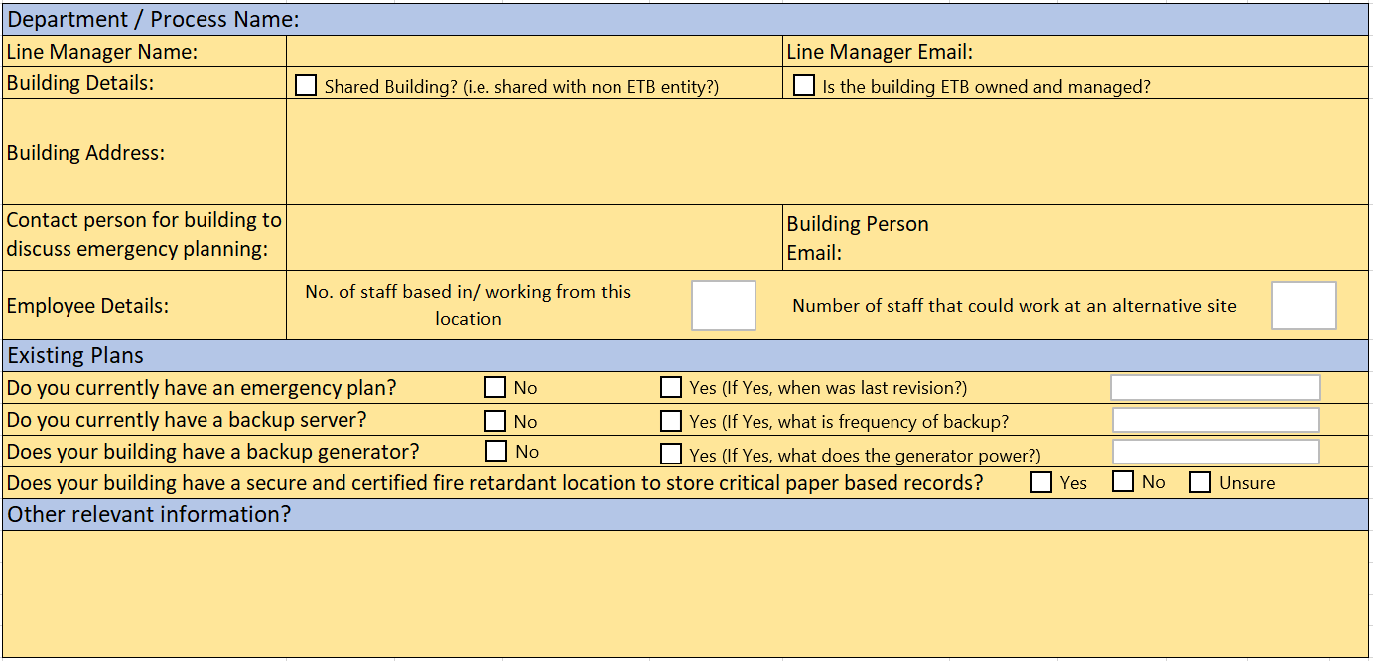

Identify Important Contacts:
Knowing who to contact in an emergency is critical. Start your business continuity by identifying the important contacts for your department or function.
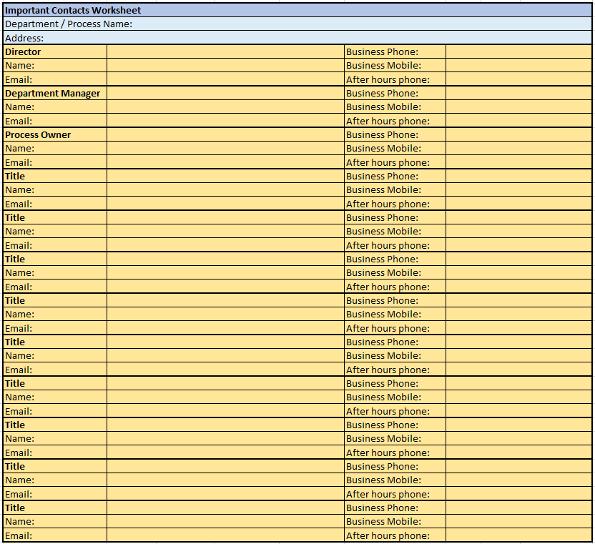

Determining Your Essential Processes / Services
A major part of business continuity is identifying processes or services that define the ETB’s operations. These are called essential processes / services, from now on to be referred to as a process. Essential processes are activities that are necessary to the on-going business of your directorate or department and would directly affect your department if they were to stop for a period of time.
Essential processes should look to identify services and functions, not business processes, for example;
- Teaching / Training / Front line student / learner services
- Regulatory / Statutory reporting obligations (Note these functions should always be regarded as critical)
Your essential processes should serve as a guide in how to restart operations following a major disruption. Once identified they should answer the question, “What is the minimum level of service my department must offer”. By identifying your essential processes, you will determine which personnel / equipment are necessary to keep the department functioning following a disaster.

Prioritising Your Essential Functions
Not all activities carry the same level of importance, some activities can be suspended for several weeks whilst others cannot stop for more than a day. Knowing the priority of your functions will help you to establish a recovery plan that can focus on these essential functions.

Important terminology
RTO – Recovery Time Objective. This is a metric that will help you to calculate how quickly you need to recover your IT infrastructure and other services in order to maintain continuity of service
RTO is effectively saying how long your identified function / department can survive before operations need to be restored to normal. For example, if your RTO is 24 hours, it implies that your business can maintain operations for that amount of time, however if data and infrastructure re not recovered within 24 hours, XXETB could suffer serious consequences.
RPO - Recovery Point Objective, is a measurement of the maximum tolerable amount of data to lose. It also helps to measure how much time can occur between your last data backup and a disaster without causing serious damage to your business. RPO is useful for determining how often to perform data backups.
Core difference: RTO reflects you overall business needs, it’s a measure of how long your business can survive with IT infrastructure and services disrupted. In contrast RPO is just about your data. It determines how often to back up your digital data and does not reflect any other IT requirements.

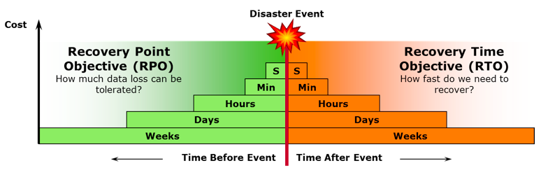
(Source: IBM, nd)

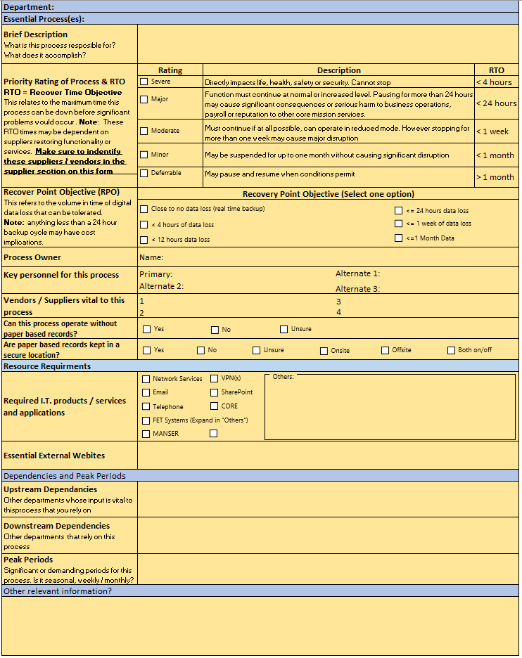
Essential Process and Business Impact Analysis Worksheet

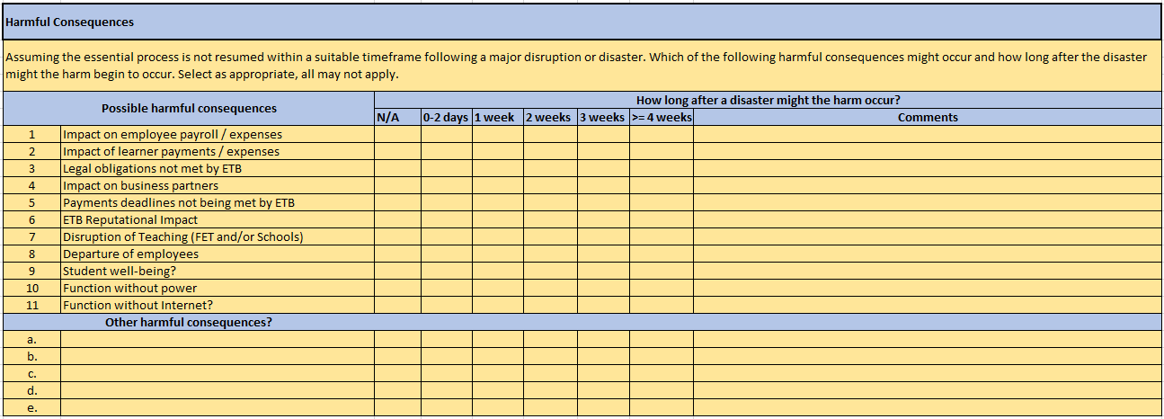

Conclusion

Thank you for your participation and contribution in helping to complete this document, this is the start of XXETBs Business Continuity Planning process.
Some of the next steps in the process at the functional level, will be to start understanding your essential resources with granular detail, with the assumption as to what is required if some of your suppliers were unable to meet their agreed SLAs or the building is unusable to a potential loss of data.
If you have concerns regarding supplier down time or supplier redundancy, please raise this issue as a matter of priority with your line manager and include in the appendix for “Relevant Information”
With that in mind, it is difficult to imagine how we could possibly work without computers or the Internet. Whether it’s a stand-alone desktop computer, laptop, tablet or even a smart phone, we depend on these resources every day. Unfortunately though, computers and systems can fail or get stolen. In these instances, the questions to start asking now, before any of these issues arise are as follows;
- Are your team saving files to a location that is regularly backed up?
  - For example, into a folder that is synced to your Microsoft One Drive account?
    - This one simple step, helps to remove hardware failure / theft as an issue for data loss
  - If using a system, i.e. HR system or payroll system, where are these master files being saved? Are they being backed up regularly and if so at what time frame, thinking all the time of your RTO/RPOs (Return time & return point objectives)
- What part of your operation relies on manual systems, i.e. paper records? Is there a digital copy of these records? If not, what is your current BCP plan around these records in the case of destruction? Is there a duplicate copy of these records kept at a different site to the original documents?
- XXETB’s ICT services will either be able to assist in the backing up of digital data or offer advice in how to do so effectively. For further information surrounding backing up of data, to understanding what data is being backed up and to general policies regarding ICT and backups, please contact and engage with your ICT services team.
- What data is regularly leaving XXETBs premises? This could be in the form of a team member taking a laptop home to work on files or a smartphone or tablet, etc. How do you ensure the safety of this data when it has left the building? Are the machines encrypted? Again, any queries here should be directed to your ICT support team and they can advise you further.

If any of the above points raise concerns, please include further information at the end of Appendix 1 “Relevant Information”

Appendix 1

Note:
- Each form is on a separate page, print as many copies as you deem necessary in order to complete the exercise.
- Should you wish to enter further information that you deem relevant to the exercise, feel free to do so, just explain any assumptions you have made and indicate which section you are referring too.
- Attempt to complete all forms / relevant sections on forms
- On completion, staple all the forms from your section and return to your local OSD director.
- This “completed form” should be signed and dated;

Document signed by:

__________________________________________________

Name (Print): ______________________________________
Title: ______________________________________
Date: ______________________________________

Department / Process Profile

Important Contacts Sheet

Essential Process and Business Impact Analysis Worksheet
Instructions: Complete one worksheet for each essential process for your department or function

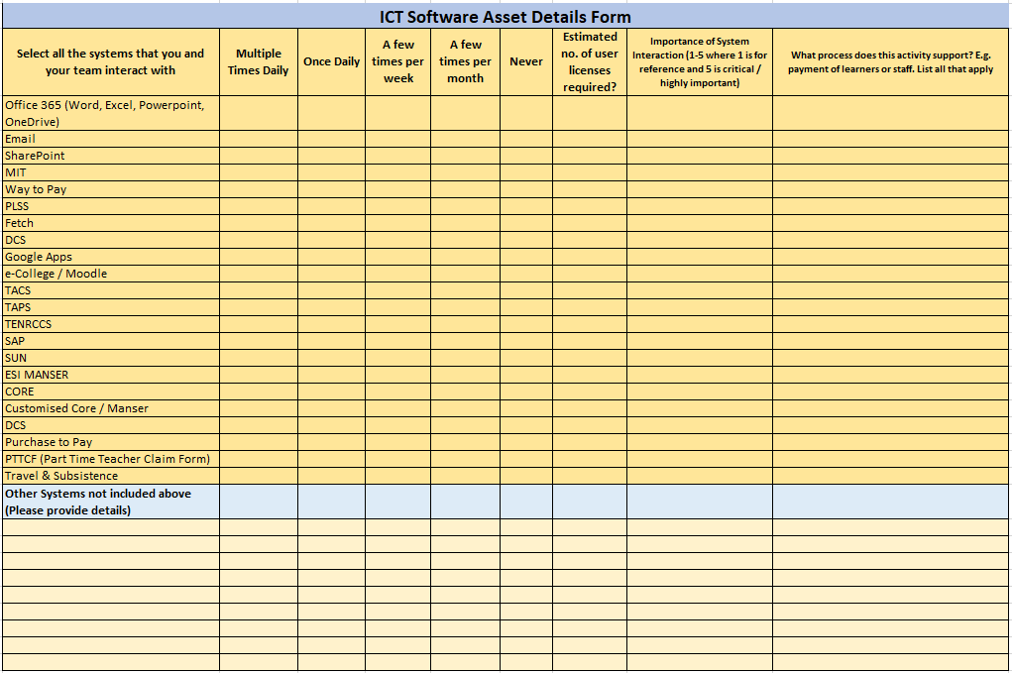

Please Provide Any Further Relevant Information

__________________________________________________________________________________

__________________________________________________________________________________

__________________________________________________________________________________

__________________________________________________________________________________

__________________________________________________________________________________

__________________________________________________________________________________

__________________________________________________________________________________

__________________________________________________________________________________

__________________________________________________________________________________

__________________________________________________________________________________

__________________________________________________________________________________

__________________________________________________________________________________

__________________________________________________________________________________

__________________________________________________________________________________

__________________________________________________________________________________
__________________________________________________________________________________

__________________________________________________________________________________

__________________________________________________________________________________

__________________________________________________________________________________

__________________________________________________________________________________

__________________________________________________________________________________

__________________________________________________________________________________

__________________________________________________________________________________

__________________________________________________________________________________

__________________________________________________________________________________

__________________________________________________________________________________

__________________________________________________________________________________

__________________________________________________________________________________

__________________________________________________________________________________

__________________________________________________________________________________

__________________________________________________________________________________

